Chat App(s)

Features

Ibrahim Ahtsham 24224

ACP  SE 5-1

Contents

Chat App 1

Version 1 (Group Chat) (Database Only) 1

Version 2 (Server-Client) (No Database) 6

# Chat App

## Version 1 (Group Chat) (Database Only)

MADE IN SWING

In this version by only using database I have made a chat app that launches and asks the user for a name that he wants to chat with

After that if the name is a new name that doesn’t previously exist in the database a new user is created against that name, and if the user name does exist then he is simply “logged in” to his chat

This Functions like a group where anyone can connect and leave messages and they will stay there

Multiple Users can connect at once

A refresh button is used to refresh the chat

### Adding new User

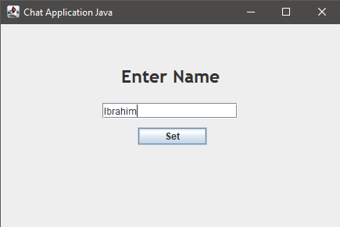

Figure 1Adding new User

### User Added

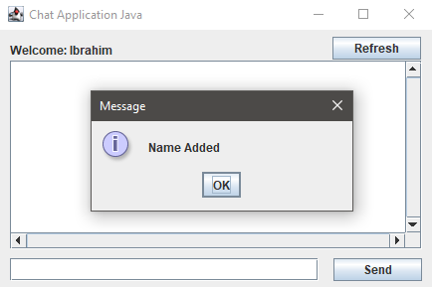

Figure 2 New User Added

### Previous Chat Loaded

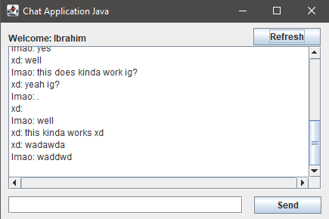

Figure 3 Previous Chat Loaded

### Typing new Message

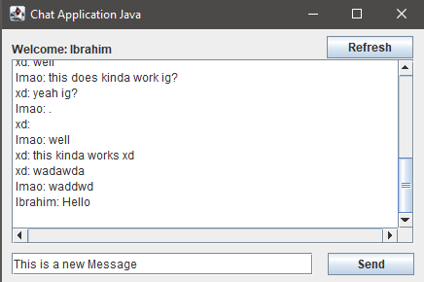

Figure 4 Inserting New Message

### New Message Inserted Into Database

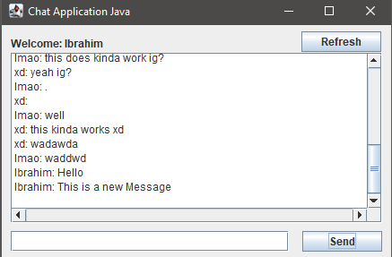

Figure 5 New message Inserted

### Logging in with existing user

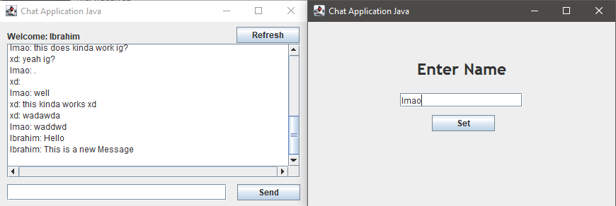

Figure 6 Opening New Instance as Already existing User

### Sending message

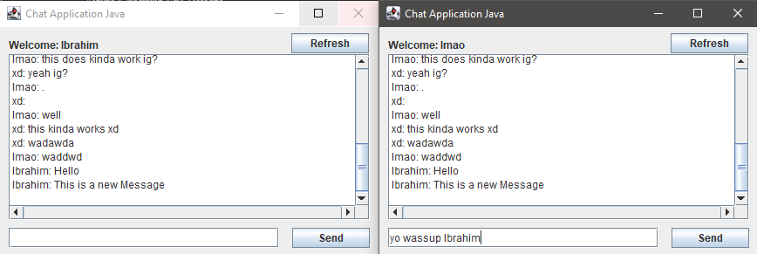

Figure 7 Sending message to group

### Message Inserted into DB but not refreshed on Ibrahim’s Side

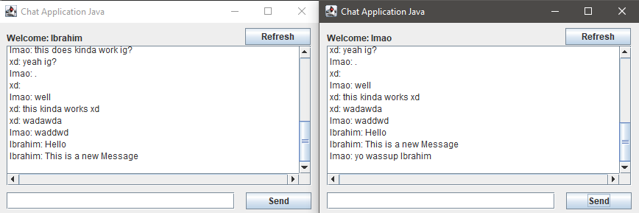

Figure 8 Message Inserted but not refreshed on "Ibrahim’s side

### Refreshed on Ibrahim’s Side

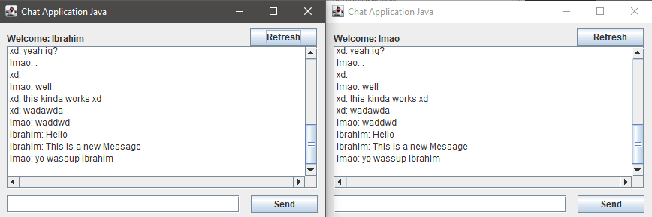

Figure 9 Message refreshed and shown at Ibrahim's side

### Ibrahim sending reply

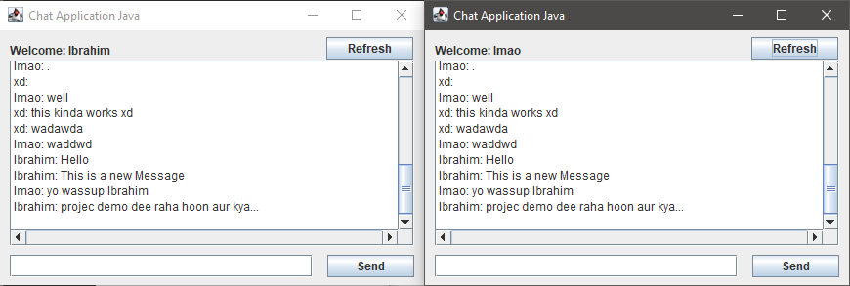

Figure 10 Message sent and refreshed on lmao's side

### Four users using the chat at once, can add as much as you want

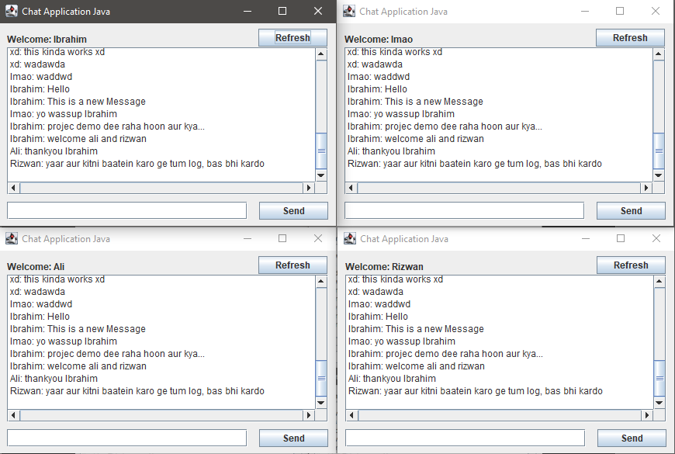

Figure 11 Four instances of chat app running at the same time

## Version 2 (Server-Client) (No Database)

MADE IN JAVAFX

In this version there is a server and a client version of the app, by using sockets and threads it is made in a way that server and client can send messages back and forth to each other

